
INSTITUTO DE TRANSPORTES E COMUNICACOES

CV4 EM TECNICO SUPORTE INFORMÁTICO
TSI-23
MGRPD
MO TIC014012

PROJECTO DE REDE LOCAL, INCLUINDO ESCOLHA DE TECNOLOGIA, ELABORAÇÃO DE DIAGRAMAS E DE ORCAMENTO

Nome do Formando: Nome do Formador:
- Kennedy Orlando José Gabriel - Sebastião Chemane

Maputo, Dezembro 2025

INDICE
1. Objectivo 1
2. Resumo do Projecto 1
3. Tecnologias utilizadas 1
4. Diagrama Lógico 2
5. Diagrama Topologico 2
6. Diagrama de Cablagem 3
8. Orçamento 4
8.1. Previsão de custo 4
8.2. Equipamentos de Rede 5
8.3. Outros Materiais 6
8.4. Mão - de - Obra 7
8.5. Resumo do Orçamento 7

Objectivo
Implementar uma Rede Local (LAN) organizada, segura e documentada num escritório com 5 salas de 150 m² cada, suportando 30 postos de trabalho (6 por sala), duas impressoras partilhadas e três servidores numa sala dedicada de 16 m². A rede deverá garantir conectividade interna, acesso à Internet, segmentação por VLANs e facilidade de manutenção.

Resumo do Projecto
O projecto propõe uma topologia em estrela com um switch central ligado ao router/firewall e aos servidores. Cada sala terá um switch de acesso ligado ao switch central. Haverá segmentação por VLANs (utilizadores, servidores, impressoras, administração) para segurança e gestão. A cablagem será em CAT6 com patch panels e rack para a sala de servidores. Inclui configuração básica de DHCP, DNS, firewall, e rotina de backups.

Tecnologias utilizadas
- Modelo OSI;
- Protocolo TCP/IP;
- VLAN;
- Equipamentos de rede

Diagrama Lógico
%3CmxGraphModel%3E%3Croot%3E%3CmxCell%20id%3D%220%22%2F%3E%3CmxCell%20id%3D%221%22%20parent%3D%220%22%2F%3E%3CmxCell%20id%3D%222%22%20edge%3D%221%22%20parent%3D%221%22%20style%3D%22endArrow%3Dnone%3Bhtml%3D1%3Brounded%3D0%3BfontFamily%3DHelvetica%3BfontSize%3D12%3BfontColor%3Ddefault%3BstartSize%3D8%3BendSize%3D8%3Bcurved%3D1%3BstrokeColor%3Dlight-dark(%23000000%2C%23000000)%3BstrokeWidth%3D8%3BentryX%3D0%3BentryY%3D0.5%3BentryDx%3D0%3BentryDy%3D0%3B%22%20value%3D%22%22%3E%3CmxGeometry%20height%3D%2250%22%20relative%3D%221%22%20width%3D%2250%22%20as%3D%22geometry%22%3E%3CmxPoint%20x%3D%22825%22%20y%3D%22318%22%20as%3D%22sourcePoint%22%2F%3E%3CmxPoint%20x%3D%22952%22%20y%3D%22316%22%20as%3D%22targetPoint%22%2F%3E%3C%2FmxGeometry%3E%3C%2FmxCell%3E%3C%2Froot%3E%3C%2FmxGraphModel%3E%3CmxGraphModel%3E%3Croot%3E%3CmxCell%20id%3D%220%22%2F%3E%3CmxCell%20id%3D%221%22%20parent%3D%220%22%2F%3E%3CmxCell%20id%3D%222%22%20edge%3D%221%22%20parent%3D%221%22%20style%3D%22endArrow%3Dnone%3Bhtml%3D1%3Brounded%3D0%3BfontFamily%3DHelvetica%3BfontSize%3D12%3BfontColor%3Ddefault%3BstartSize%3D8%3BendSize%3D8%3Bcurved%3D1%3BstrokeColor%3Dlight-dark(%23000000%2C%23000000)%3BstrokeWidth%3D8%3BentryX%3D0%3BentryY%3D0.5%3BentryDx%3D0%3BentryDy%3D0%3B%22%20value%3D%22%22%3E%3CmxGeometry%20height%3D%2250%22%20relative%3D%221%22%20width%3D%2250%22%20as%3D%22geometry%22%3E%3CmxPoint%20x%3D%22825%22%20y%3D%22318%22%20as%3D%22sourcePoint%22%2F%3E%3CmxPoint%20x%3D%22952%22%20y%3D%22316%22%20as%3D%22targetPoint%22%2F%3E%3C%2FmxGeometry%3E%3C%2FmxCell%3E%3C%2Froot%3E%3C%2FmxGraphModel%3E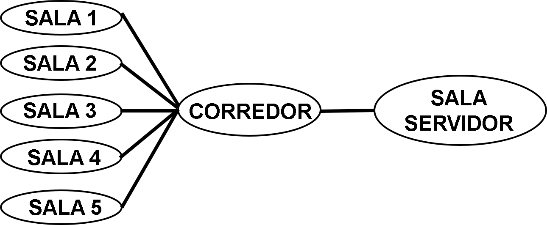

Diagrama Topologico
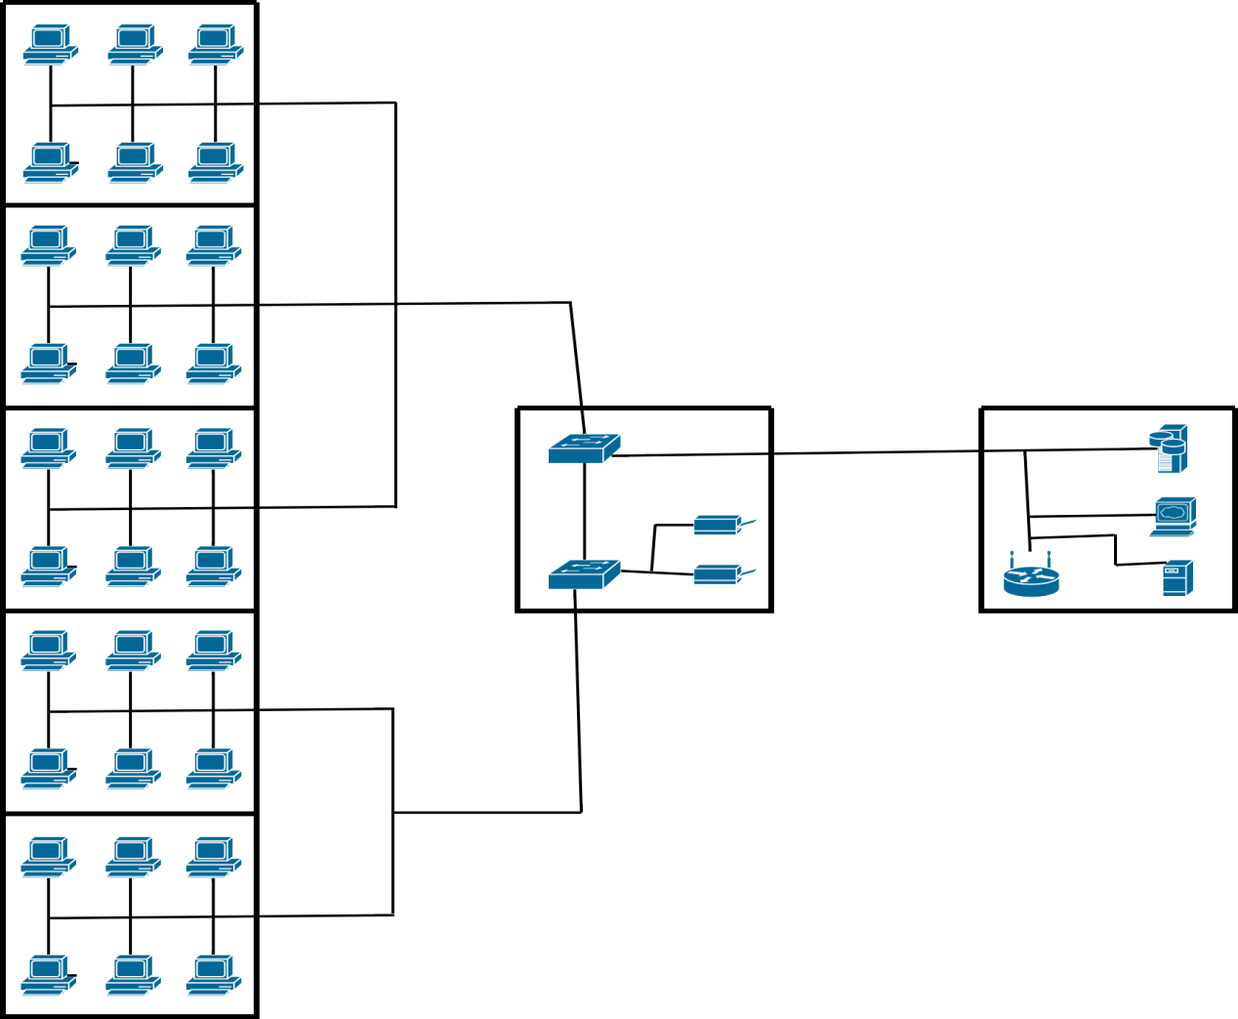

Diagrama de Cablagem
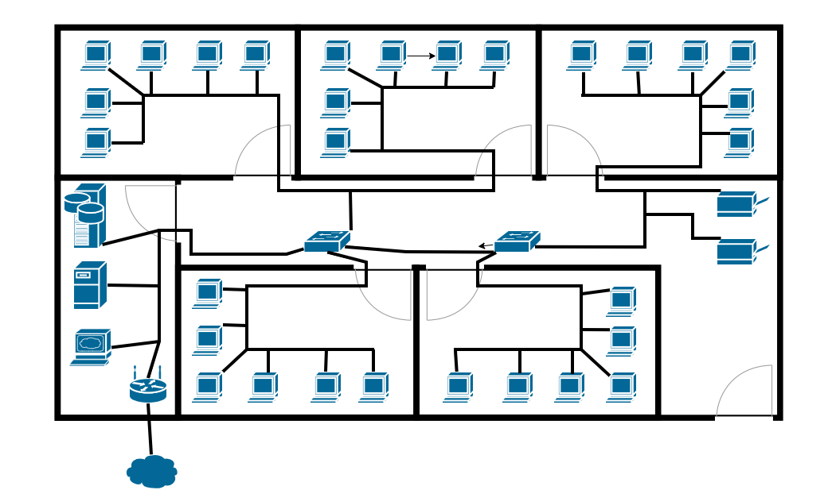

- Legenda
%3CmxGraphModel%3E%3Croot%3E%3CmxCell%20id%3D%220%22%2F%3E%3CmxCell%20id%3D%221%22%20parent%3D%220%22%2F%3E%3CmxCell%20id%3D%222%22%20parent%3D%221%22%20style%3D%22text%3BstrokeColor%3Dnone%3BfillColor%3Dnone%3Bhtml%3D1%3Balign%3Dcenter%3BverticalAlign%3Dmiddle%3BwhiteSpace%3Dwrap%3Brounded%3D0%3BfontSize%3D12%3BfontFamily%3DHelvetica%3BfontColor%3Dlight-dark(%23000000%2C%23000000)%3B%22%20value%3D%22%26lt%3Bfont%26gt%3B%26lt%3Bspan%20style%3D%26quot%3Bfont-size%3A%2050px%3B%26quot%3B%26gt%3BComputador%26lt%3B%2Fspan%26gt%3B%26lt%3B%2Ffont%26gt%3B%22%20vertex%3D%221%22%3E%3CmxGeometry%20height%3D%2230%22%20width%3D%2260%22%20x%3D%22291.9999084472656%22%20y%3D%2260.99993896484375%22%20as%3D%22geometry%22%2F%3E%3C%2FmxCell%3E%3C%2Froot%3E%3C%2FmxGraphModel%3E%3CmxGraphModel%3E%3Croot%3E%3CmxCell%20id%3D%220%22%2F%3E%3CmxCell%20id%3D%221%22%20parent%3D%220%22%2F%3E%3CmxCell%20id%3D%222%22%20parent%3D%221%22%20style%3D%22text%3BstrokeColor%3Dnone%3BfillColor%3Dnone%3Bhtml%3D1%3Balign%3Dcenter%3BverticalAlign%3Dmiddle%3BwhiteSpace%3Dwrap%3Brounded%3D0%3BfontSize%3D12%3BfontFamily%3DHelvetica%3BfontColor%3Dlight-dark(%23000000%2C%23000000)%3B%22%20value%3D%22%26lt%3Bfont%26gt%3B%26lt%3Bspan%20style%3D%26quot%3Bfont-size%3A%2050px%3B%26quot%3B%26gt%3BComputador%26lt%3B%2Fspan%26gt%3B%26lt%3B%2Ffont%26gt%3B%22%20vertex%3D%221%22%3E%3CmxGeometry%20height%3D%2230%22%20width%3D%2260%22%20x%3D%22291.9999084472656%22%20y%3D%2260.99993896484375%22%20as%3D%22geometry%22%2F%3E%3C%2FmxCell%3E%3C%2Froot%3E%3C%2FmxGraphModel%3E
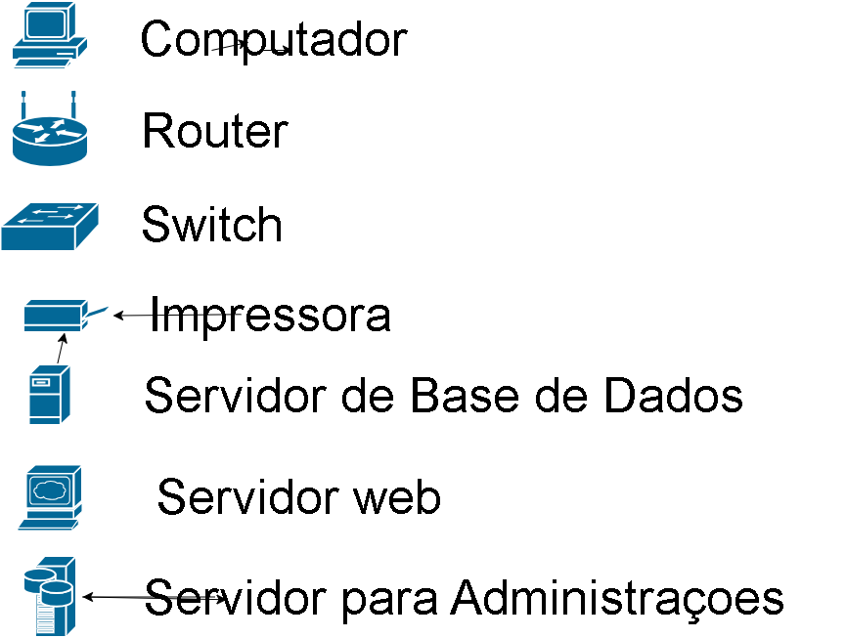

Orçamento

Previsão de custo
- Equipamento de rede;
- Outros materiais;
- Mão-de-obra.

Equipamentos de Rede
Equipamento | Localizacao | Quantidade | Preço/Unidade | Total
Desktop CI5, 10G, 8GB | Salas (1-5) | 30 | 36,000.00 | 1,080,000.00
Monitor 24 polegas | Salas (1-5) | 30 | 13,200.00 | 396,000.00
Teclado, Mouse Wireless | Salas (1-5) | 30 | 1,300.00 | 39,000.00
Impressora HP 137 FMW | Corredor | 1 | 21,000.00 | 21,000.00
Impressora HP 581 | Corredor | 1 | 17,500.00 | 17,500.00
Router Dauha DH MR403 | Sala Servidor | 1 | 2,800.00 | 2,800.00
TP-Link 24 Port 10/100Mbps Fast Ethernet Switch | Corredor | 2 | 6,900.00 | 13,800.00
Servidor de Base de Dados | Sala Servidor | 1 | 85,000.00 | 85,000.00
Servidor Para Administracoes | Sala Servidor | 1 | 85,000.00 | 85,000.00
Servidor de Web | Sala Servidor | 1 | 85,000.00 | 85,000.00
Total |  | 4 |  | 1,825,100.00

Outros Materiais
Material | Unidade | Quantidadde | Preço/Unidade | Total
CABO INFORMATICO UTP CAT6 cca MATEL (Rolo 305m) | Rolo | 2 | 5,700.00 | 11,400.00
FICHA INFORMATIC RJ45 UTP 8P8C MATEL 4049 HK | Peca | 75 | 9.00 | 675.00
PROTECCAO BORRACHA P/FICHA RJ45 (BOTAS) CINZENTA MATEL 4139 | Peca | 75 | 7.50 | 562.50
CALHA CLIPAGEM DIRETA 100X50 BR 11020 CBR EFAPEL | Caixa | 40 | 1210.00 | 48,400.00
Total |  |  |  | 61,037.50

Mão - de - Obra
Mao-de-obra | Previsão de Horas | Preco/Hora | Total
Equipa de Instalação | 20 | 1,000.00 | 20,000.00
Equipa de de Rotulagem | 3 | 800.00 | 2,400.00
Equipa de Certificação de Fluxo de Rede | 3 | 1,500.00 | 4,500.00
SUB-Total |  |  | 26,900.00
Margem de Erro 5% |  |  | 1,345.00
Total |  |  | 28,245.00

Resumo do Orçamento
Item | Total
Equipamento | 1,825,100.00
Material | 61,037.50
Mao-de-obra | 28,245.00
Total | 1,914,382.50

